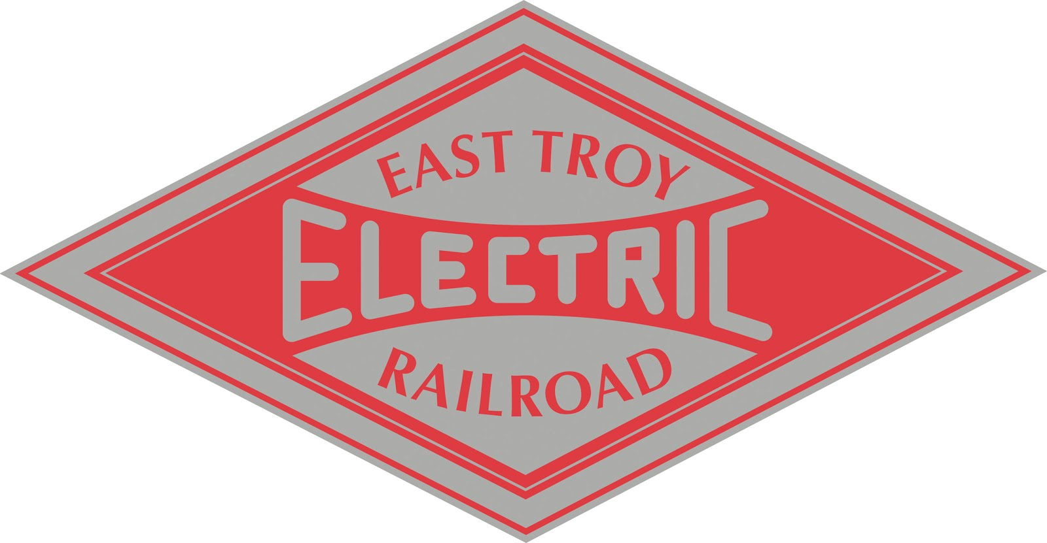
FOR IMMEDIATE RELEASE Contact: Steve Thomas
April 13, 2019 sthomas@easttroyrr.org
414-702-6257

East Troy Electric Railroad Set for Opening Day on April 27th

EAST TROY, WI - The depot is open, our historic cars are cleaned and polished, the long winter has come to an end, and the East Troy Electric Railroad is ready to kick off its 2019 season on Saturday, April 27th. Trains will depart on the hour from the East Troy Depot starting at 10am. The last train departs at 3pm. Trains run every Saturday and Sunday through the first weekend in November. They will run three times a day on Fridays starting May 31st.

The East Troy Electric Railroad operates on the last 7 miles of the original track from The Milwaukee Electric Railway & Light Company interurban system, which used to have over 200 miles of track in and around Milwaukee. For more than 50 years, starting in 1905, trains left from the Public Service Building at 3rd and Michigan in Milwaukee and whisked passengers to and from cities and towns throughout southeastern Wisconsin, including Waukesha, Burlington, Port Washington, Sheboygan, Watertown, Kenosha, Racine and East Troy.

The Public Service Building is still there. It’s now part of the headquarters for WE Energies, which is the company that emerged from the original Milwaukee Electric Railway & Light Company. But the tracks are gone, except between East Troy and Mukwonago, where you can still experience what it was like to ride interurban trains between Milwaukee and the cities and towns north, south, and west of the city.

Prices for the round-trip rides are $8 for kids, $12.50 for adults, and $10.50 for seniors. One ticket is good for rides on the trains all day. One round trip takes approximately 90-minutes. Trains stop at the Elegant Farmer in Mukwonago, which is a popular spot for farm-fresh produce, cheese, and the famous Apple Pie Baked in a Paper Bag®. The trains are heated and there are restrooms inside the East Troy Depot.
____________________________________________________________________________________________________

More About Us: The East Troy Railroad Museum operates 14-mile round trip excursions from its historic East Troy depot and museum to Indianhead Park in Mukwonago, with a stop at the popular Elegant Farmer store and deli. This year the railroad is celebrating 112 years of electric railroading through Southeast Wisconsin’s Kettle Moraine countryside. This 501(c)(3) not-for-profit railroad museum is operated and managed by over 140 volunteers committed to the operation and preservation of historic trolleys and interurban railcars. For more information, visit www.easttroyrr.org or call 262.642.3263.

# # #

