Frequently Asked Questions

Q: How many trolleys or other railroad cars do you have at the railroad and museum?
A: We have 26 electric railroad cars, trolleys and locomotives and one crane for repairs.

Q: Are all the cars and trolleys running?
A: Fourteen of the 26 pieces of railroad equipment are in service. We started restoration work on two more cars in 2020 and hope to have them running by late 2021.

Q: What is the oldest trolley or railroad car that you have? When was it built?
A: Our oldest car is more than 125 years old. Car No. 17 was built in the 1880s as horse-drawn trolley car for the Milwaukee Street Railway.

Q: How old is the East Troy railroad line?
A: The railroad line to East Troy was completed on December 13th of 1907, making it almost 114 years old.

Q: How many volunteers do you have at the East Troy Electric Railroad Museum?
A: We have about 135 regular volunteers. They do everything from rebuilding the railroad cars to maintaining the electric lines that power the trains to serving drinks on a dinner train to cleaning the cars after each use. They also run the museum and gift shop.

Q: Is there any paid staff at the East Troy Electric Railroad Museum?
A: Yes, we now have one paid staff member, Jim Feyerherm, our Operations Manager. Everyone else is a volunteer. All the proceeds from ticket sales, dinner trains, gift shop sales and donations go right back into maintaining the railroad.

Q: How many people ride on the East Troy Electric Railroad each year?
A: In 2019 just under 24,000 people rode one of our regular or specialty trains. However in 2020 we had just 6,600 riders due to the COVID-19 Pandemic.

Q: Do you have a regular schedule for when your trains and trolleys run?
A: Yes. The railroad runs regularly scheduled trains every Saturday and Sunday from late April through late October. From early June to late October trains run on Fridays too, departing East Troy at 10am, noon and 2pm.

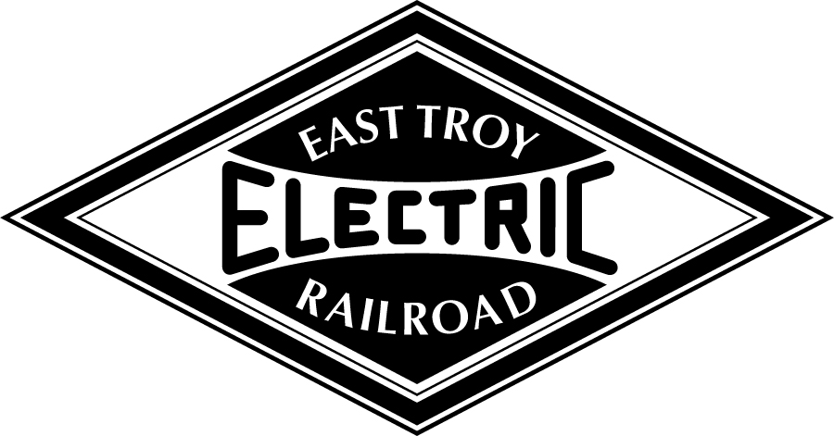
Media Contact: Steve Thomas at 414-702-6257

Museum Location: 2002 Church Street, East Troy, WI 53120
Mailing Address: P.O. Box 943, East Troy, WI 53120-0943
Main Phone: 262-642-3263
Website: easttroyrr.org

