|  |  |
| --- | --- |
| **Officers and Directors of the East Troy Railroad Museum**  **Officers:**  **Ryan Jonas**, President  **Bill Finke**, Vice President & General Counsel  **Steve Thomas**, Secretary  **Ron Knaflic**, Treasurer  **Board of Directors:**  **Pat Doran (Chairman)**  **Bernard Van Dinter**  **Dan Behr**  **Joseph Buerger**  **Steve Southworth**  **Zach Frame**  **John Giove**  **Brad Ellefson**  **Ed Stayanovich**  **Steve Rudolph**  **Department Managers:**  *Operations Manager*  **Jim Feyerherm**  *Dinner Trains / Charters*  **Jim Feyerherm / Lindsay Jonas**  *Depot / Gift Shop*  **Lisa Jonas / Steve Hitt**  *Maintenance & Restoration Chair*  **John Jonas**  *Maintenance of Way*  **Steve McCarthy**  *Overhead Maintenance*  **Steve Southworth and Zach Frame**  *Marketing Chair*  **Steve Thomas** |  |

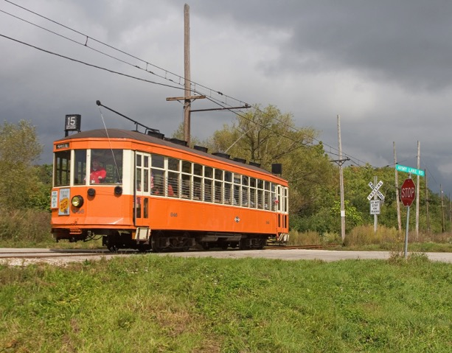

**Museum Location:**

2002 Church Street, East Troy, WI  53120

**Mailing Address:**

P.O. Box 943, East Troy, WI  53120-0943

**Main Phone:** 262-642-3263

**Website:** easttroyrr.org